

COURSE: DSA0406- Fundamentals of Data Science

Name | S Anudeep Sai
Register Number | 192472066
Date | 06.10.2026

EXPERIMENT-1:
How would you use NumPy arrays to calculate the average score for each subject and determine the subject with the highest average score? Assume 4x4 matrix that stores marks of each student in given order.
Aim :
To perform basic operations on NumPy arrays and calculate statistical measures such as the average using NumPy functions and array operations.
Program :
import numpy as np
student_scores = np.array([
[85, 78, 90, 75],
[76, 82, 85, 80],
[90, 88, 92, 85],
])
subject_averages = np.mean(student_scores, axis=0)
subjects = ["Math", "Science", "English", "History"]
for subject, average in zip(subjects, subject_averages):
print(subject, "Average:", average)
highest_subject = subjects[np.argmax(subject_averages)]
print("\nSubject with highest average:", highest_subject)

Output :
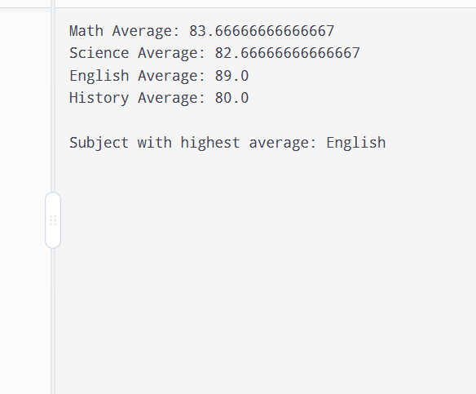
Result :
Thus, the required operations on NumPy arrays were successfully performed, and the average value was calculated using NumPy functions.

EXPERIMENT-2:
How would you find the average price of all the products sold in the past month? Assume 3x3 matrix with each row representing the sales for a different product

Aim :
To use NumPy arrays and Boolean indexing to filter house data and calculate the average sale price of houses having more than four bedrooms.
Program:
import numpy as np
sales = np.array([
[100, 120, 150],
[200, 180, 220],
[300, 250, 280]
])
average = np.mean(sales)
print("Average price:", average)

Output:
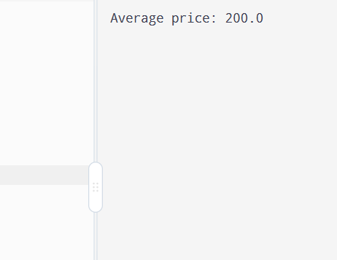

Result :
Thus, the house data was successfully filtered using NumPy Boolean indexing, and the average sale price of houses with more than four bedrooms was calculated.

EXPERIMENT-3:
Using NumPy arrays and operations, how would you find the average sale price of houses with more than four bedrooms in the neighborhood?
Aim :
To create and manipulate NumPy arrays and perform basic array operations such as indexing, slicing, reshaping, and mathematical calculations.
Program :
import numpy as np
bedrooms = np.array([3, 5, 4, 6, 5, 2, 7])
prices = np.array([200000, 350000, 280000, 500000, 400000, 150000, 600000])
selected_prices = prices[bedrooms > 4]
average_price = np.mean(selected_prices)
print("Average sale price:", average_price)
Output:
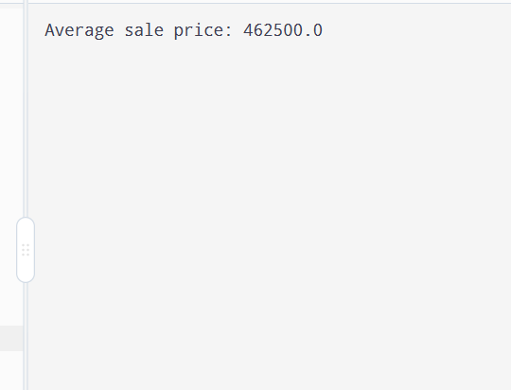

Result :
Thus, NumPy arrays were successfully created and manipulated using indexing, slicing, reshaping, and basic mathematical operations.

Experiment-4:
Using NumPy arrays and arithmetic operations calculate the total sales for the year and determine the percentage increase in sales from the first quarter to the fourth quarter?
Aim:
To calculate the total annual sales and determine the percentage increase in sales from the first quarter to the fourth quarter using NumPy arrays and arithmetic operations.
Program:
import numpy as np
sales = np.array([10000, 12000, 15000, 18000])
total_sales = np.sum(sales)
percentage_increase = ((sales[3] - sales[0]) / sales[0]) * 100
print("Total sales for the year:", total_sales)
print("Percentage increase from Q1 to Q4:", percentage_increase, "%")
Output:
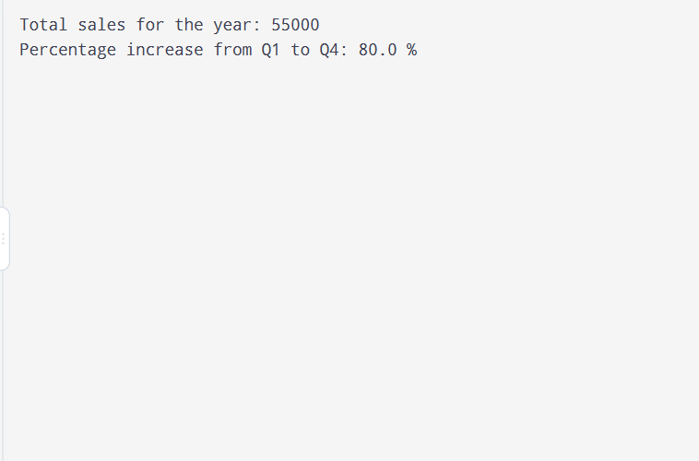
Result:
Thus, the total sales for the year and the percentage increase in sales from the first quarter to the fourth quarter were successfully calculated using NumPy arrays and arithmetic operations.

Experiment-5:
How would you use NumPy arrays and arithmetic operations to calculate the average fuel efficiency and determine the percentage improvement in fuel efficiency between two car models?
Aim:
To use NumPy arrays and arithmetic operations to calculate the average fuel efficiency of two car models and determine the percentage improvement in fuel efficiency between them.
Program :
import numpy as np
car1 = np.array([15, 16, 14, 15, 16])
car2 = np.array([18, 19, 17, 18, 19])
avg_car1 = np.mean(car1)
avg_car2 = np.mean(car2)
improvement = ((avg_car2 - avg_car1) / avg_car1) * 100
print("Average fuel efficiency of Car 1:", avg_car1, "km/l")
print("Average fuel efficiency of Car 2:", avg_car2, "km/l")
print("Percentage improvement:", improvement, "%")
output:
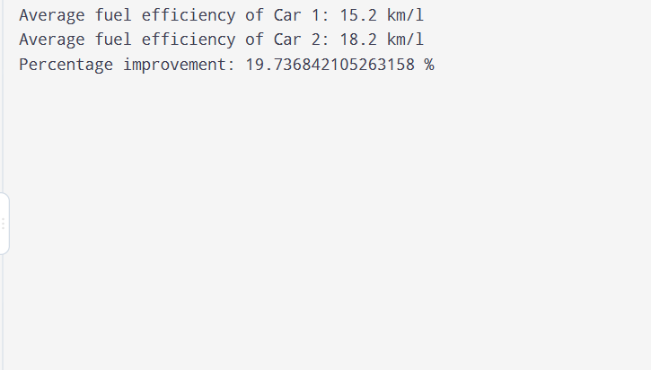
Result:
Thus, the average fuel efficiency of both car models and the percentage improvement between the two models were successfully calculated using NumPy arrays and arithmetic operations.

EXPERIMENT-6
Use arithmetic operations to calculate the total cost of a customer's purchase, including discounts and taxes, given the item prices, quantities, discount rate, and tax rate?
Aim:
To use arithmetic operations to calculate the total cost of a customer's purchase by considering item prices, quantities, discount rate, and tax rate.
Program:
price1 = 500
price2 = 300
quantity1 = 2
quantity2 = 3
discount_rate = 10 # 10%
tax_rate = 5 # 5%
subtotal = (price1 * quantity1) + (price2 * quantity2)
discount = subtotal * discount_rate / 100
amount_after_discount = subtotal - discount
tax = amount_after_discount * tax_rate / 100
total_cost = amount_after_discount + tax
print("Subtotal:", subtotal)
print("Discount:", discount)
print("Tax:", tax)
print("Total Cost:", total_cost)

output:
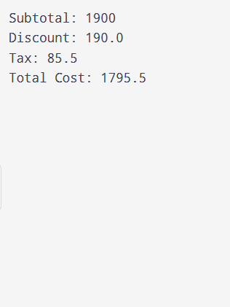

Result:
Thus, the total purchase cost was successfully calculated by applying the specified discount and tax rates using arithmetic operations.

